**FUSE bits Setting example for External Crystal 8-16 MHz**

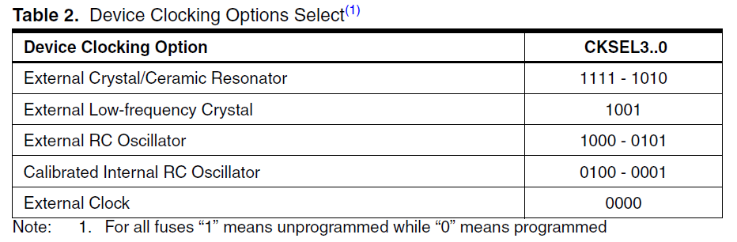

The Watchdog Oscillator is used for timing this real-time part of the start-up time.

The device is shipped with CKSEL = “0001” and SUT = “10” (1MHz Internal RC Oscillator, slowly rising power).

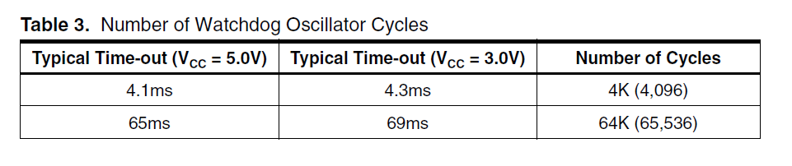

The CKOPT Fuse selects between two different Oscillator amplifier modes.

When CKOPT is **programmed**, the Oscillator output will oscillate a full rail-torail swing on the output. This mode is suitable when operating in a very noisy environment orwhen the output from XTAL2 drives a second clock buffer. This mode has a wide frequencyrange.

When CKOPT is **unprogrammed**, the Oscillator has a smaller output swing. This reduces power consumption considerably. This mode has a limited frequency range and it cannot be used to drive other clock buffers.

The maximum frequency is **8MHz** with CKOPT unprogrammed and **16MHz** with CKOPT programmed

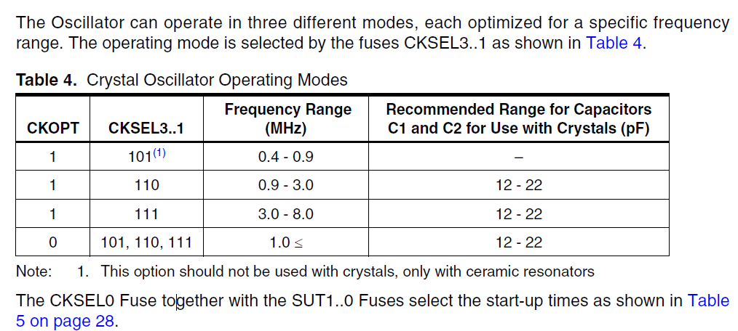

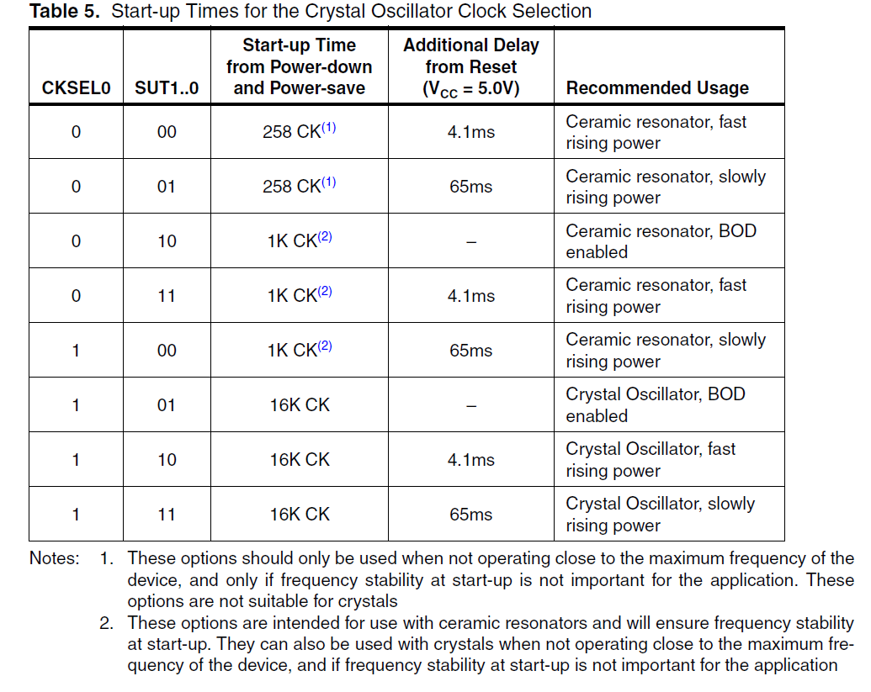

Select **Slowly** rising power so that the uc get appropriate time to stablize before executing the first operation. Microcontroller need to some time to stablize its clocks after power save or reset to execute instruction properly else could be misbehave is expected.

In this case select 1 11 – 65mSec Crystal Oscillator, Slowly rising power

**CSEL0 and SUT1..0**

* For 8 and 16MHz external Crystal values will be same [ 1,11]

**CKOPT and CSEL3..1**

* For 8MHz and external Crystal value will be [1,111]
* For 8< and >16 MHz values will be[0,101or110]
* For 16 MHz values will be [0,111]

**FUSE Bits**

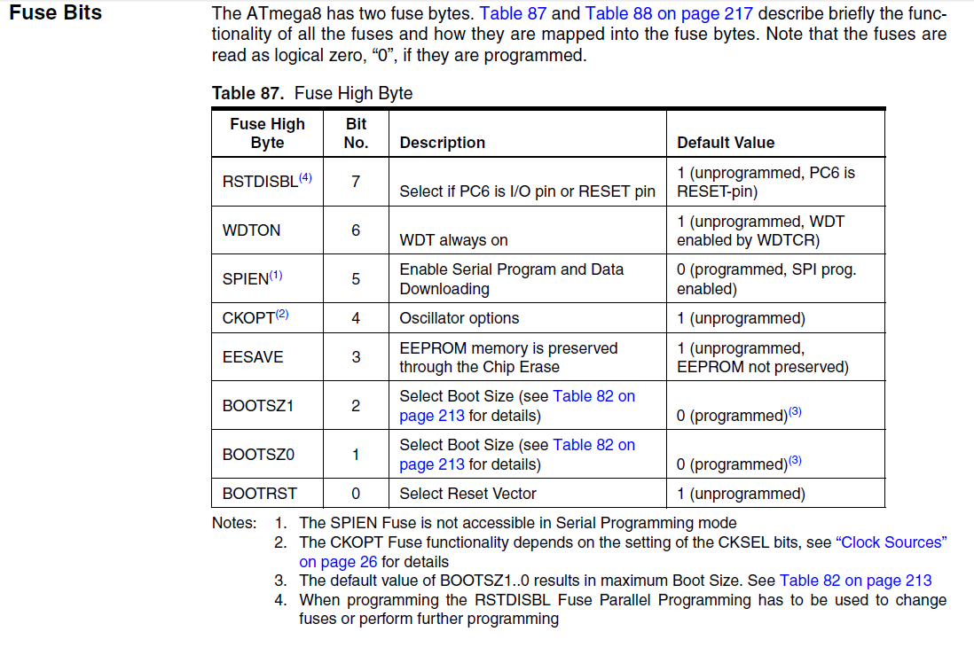

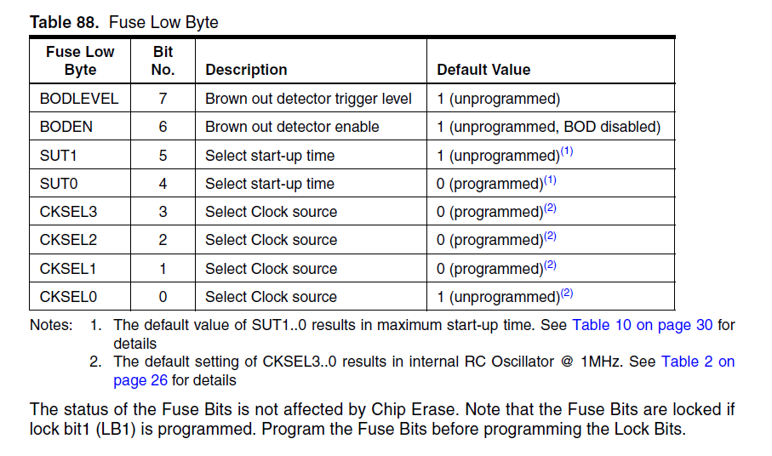

**Fuse bit setting with internal 8MHz Crystal**

**Calibrated Internal RC Oscillator**

* The calibrated internal RC Oscillator provides a fixed 1.0MHz, 2.0MHz, 4.0MHz, or 8.0MHz clock.
* This clock may be selected as the system clock by programming the CKSEL Fuses as shown in Table 9. If selected, it will operate with no external components. The CKOPT Fuse should always be unprogrammed when using this clock option.
* During reset, hardware loads the 1MHz calibration byte into the OSCCAL Register and thereby automatically calibrates the RC Oscillator

